**LAB – 3 Assignment**

**Name:** L V SANDEEP BATHINA(16174348)

1)

Download Opera Mobile Emulator

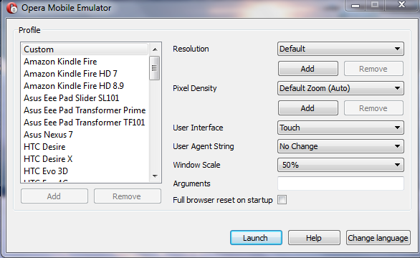

Jsfiddle code: <http://jsfiddle.net/lbzv9/FrvLV/96/>

Debug the code on the emulator as below

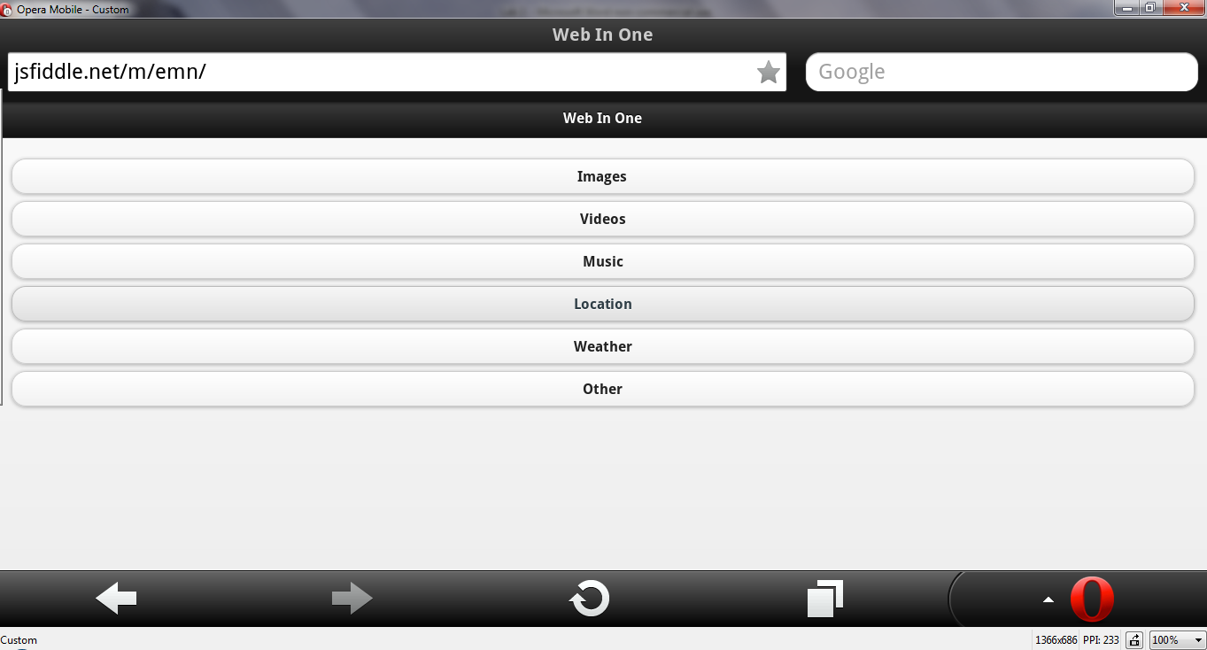

Click on Images as below

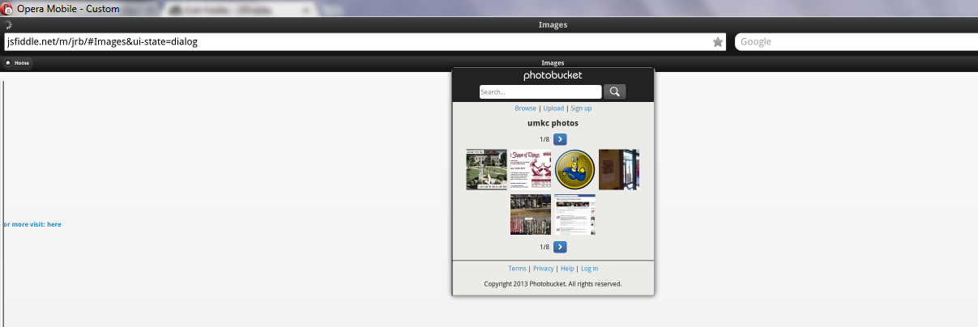

Click on Videos as below

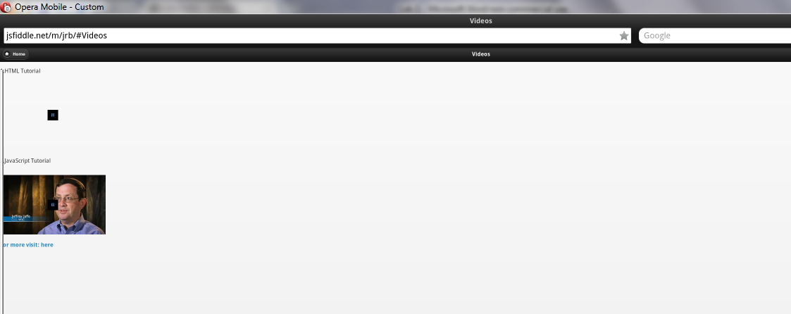

Click on music

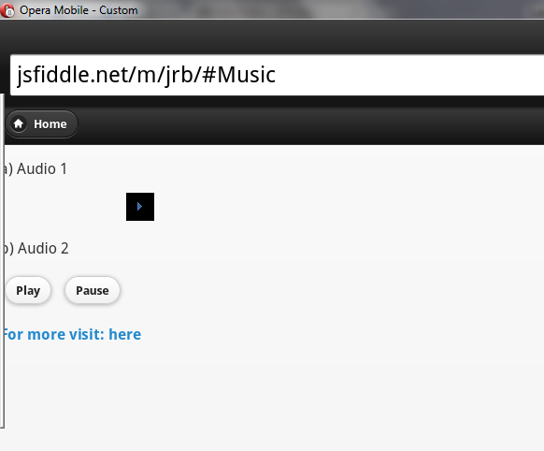

Here I have implemented the Google services for Location and weather.

Click on Location and it displays your present location as below

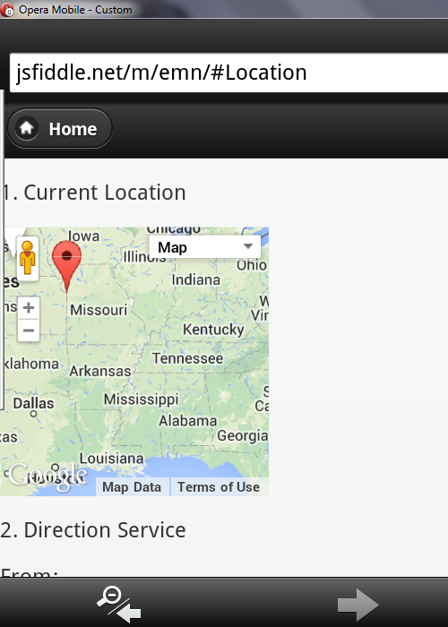

In Location service, Enter the from and to location to find the route map between those places.(Ex: Newyork to chicago)

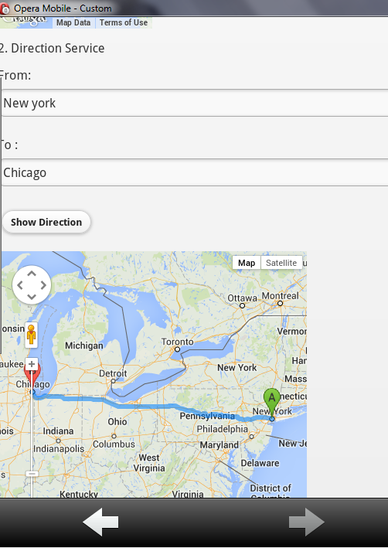

Click on weather service, Enter the state and the city you are interested to find the temperature.(Ex: state-Illinois,City-Chicago)

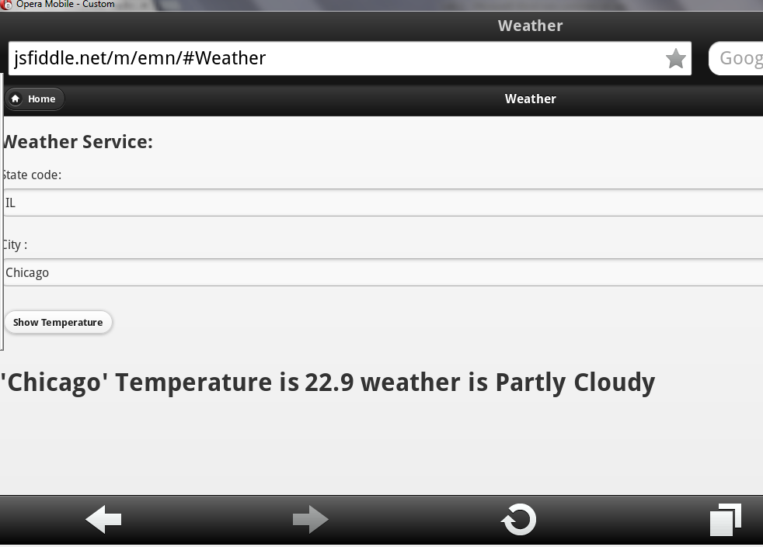

2) Download VM player

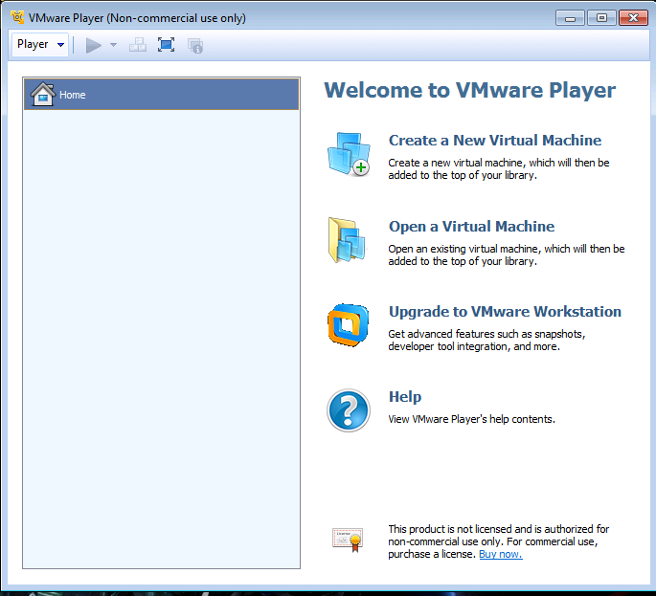



Open Terminal and download Zip files for hadoop Wordcount example and Mahout installation

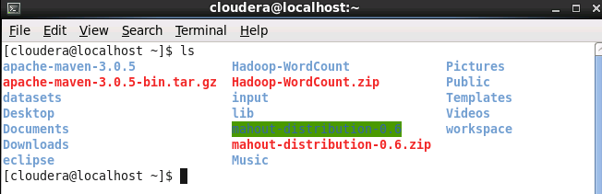

Wordcount example output

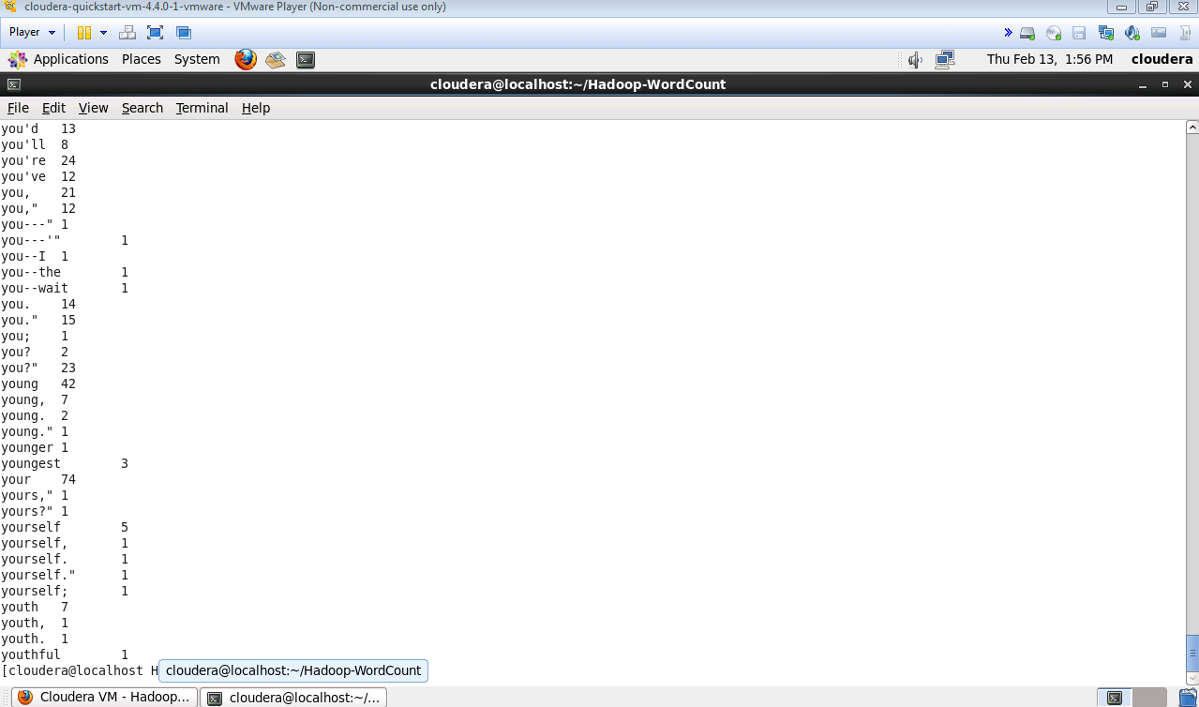

Mahoot example output

